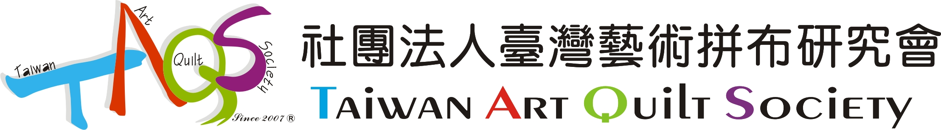

Taiwan International Quilt Exhibition 2012 Entry Prospectus
This Prospectus is Only For Taiwan Area

Subsequent to the TIQE2009 (Website: http://www.taqs.org.tw/tiqe2009/), TAQS will organize an international art quilt exhibition possessed of artistic and educational quality. TIQE2012 will focus on global issues and highlight the creation of quilting is not only the interpretation of techniques but also the contemporary artistic merit of environmental care and the spirit of humanities.

Location: (1) National Tainan Living Art Center, Tainan City, Taiwan
Dates: August 11-September 7, 2012
(2) Taichung County Culture Center, Feng Yuan District, Taiwan
Dates: September 22-October 29, 2012
Additional venues will be added

[Calendar]
April 15, 2011 | Call for entry announced
February 03, 2012 | Entry deadline(Postmark)
February 29, 2012 | Notification of acceptance via email and announcement on website at http://www.taqs.org.tw/
March 09, 2012 | Deadline for re-submitting unqualified images of selected artwork
April 10, 2012 | Participation fee and artwork to be RECEIVED at TAQS
August 11, 2012 | Exhibition opens in Tainan City/ opening reception
September 7, 2012 | Exhibition closes in Tainan City
September 22, 2012 | Exhibition opens in Feng Yuan District
October 29, 2012 | Exhibition closes in Feng Yuan District
December 14, 2012 | Return artwork to artists

Theme:
I-Moving Water and River
Water and rivers are full of life and nutrient: novelty, freshness, and sustainability symbolize a source of vitality, expecting to convey an energetic, broad, and microcosmic angle of view, as well as each kind of life and existence that water and river embrace.

II-Surpassing Geometry
Learning geometry is a stating point to every quilter; creating quilts is surpassing learning paths, limits, and extending as far as time and space.

Curator: Lin Hsin-Chen
Lin Hsin-Chen is President of TAQS. Born and grown up in Taiwan, she is a fiber artist who has been devoting herself to creation, organizing exhibitions and teaching for 20 years. She often leads students or groups to work together on large-sized collective works. Global environmental issues are always her concerns so she puts her observation and reflection into her works.
(Website: http://www.linhsinchen.idv.tw/). Fiber art is creations of integration encompassed a culture of life. She puts all her effort into expanding her horizons to achieve the goal for design and makes every detail well-connected to one another. To go beyond the limitation, sometimes she has to break the given standards to pursue the ultimate spirit.

Eligibility and Guidelines:

1. Open to the residents of Taiwan and native Taiwanese, over the age of 20
2. Theme I: Moving Water and River
A: Individual: Works must be based on water and river concept and created by
individual(s).
Size of Works: Entries must be a maximum of 200cm (79”) per side. A label including artist name and the title of work securely attached on the back bottom corner of work. Accepted works should be ready for hanging with a 12 cm( 5”) wide sleeve attached to the back at the top of work.
B: Groups: Works must be based on water and river concept and created by group(s).
Size of Works: Collective entries must be a maximum of 200cm (79”) per side. A label including artist(s) name and the title of work securely attached on the back bottom corner of work. Accepted works should be ready for hanging with a 12 cm ( 5”) wide sleeve attached to the back at the top of work.
3. Theme II: Surpassing Geometry
A: Individual: Works must be based on “Surpassing Geometry”.
Size of Works: Only 50 cm x 50 cm (20”x 20”) works are accepted. A label including artist name and the title of work securely attached on the back bottom corner of work. Accepted works should be ready for hanging with a 12 cm (5”) wide sleeve attached to the back at the top of work.

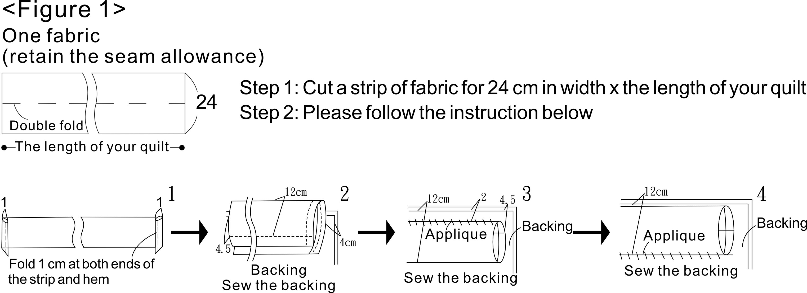

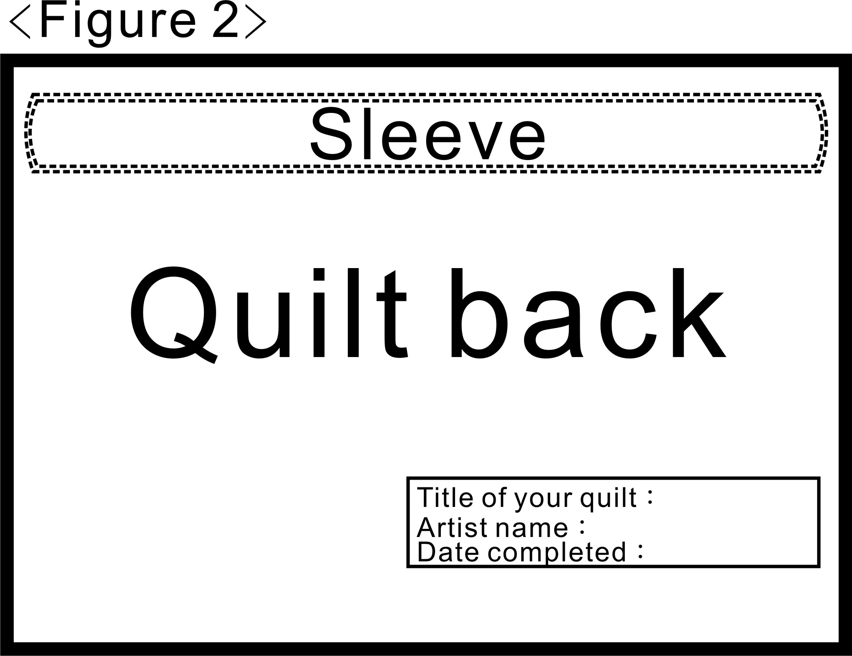
4. Works must meet the definition of following:
A: An art quilt creation is an exploration and expression of an aesthetic of visual arts. Works must consist of a top, the batting, the backing and these three layers must be sewn together by hand or machine quilting.
B: Works that contain classic significance, innovation, exquisite traditional techniques, aesthetic value, cultural connotation, expressing experience and reflection toward of life.
C: Originality:
(1): Work must be created by the artist(s). No plagiarism, reproduction and encroach copyrighted artwork without permission. Artist(s) is responsible for any illegal issues and copyright infringement and an announcement of disqualificated artist(s) will be posted on TAQS website.
(2): Only accept individual work(s) and collective work(s) that contain the original concept, pattern, and completion created by the participator(s). (Please indicate the name of the original designer(s) and the name of the participator(s).
(3): Using, reproducing, and modifying a pattern made by others will NOT be accepted.
5. Qualification:
75 %: Creation concept, sewing techniques, materials used, completeness of your work(s).
25 %: Written narratives (artist statement and creative concepts).
6. 3-D, free-standing works will NOT be accepted.
7. You may submit up to 3 entries for each theme.
8. Fee:
A: Entry fee: 2,000 NTD for submitting up to 6 entries.
B: When your entries are selected, participation fee of 3, 000 NTD for each of your selected entries to be exhibited at TIQE2012 will have to cover the expense such as publicity, installation, and publication.
C: Please remit the both entry fee and participation fee to :
匯款戶名:社團法人台灣螞蟻拼布研究會
(Account name: Taiwan Ant Quilt Society)
匯款帳號:104540058188
(Account number: 104540058188)
銀行名稱:中國信託中台南分行(代號:822)
(Bank name: Chinatrust Central Tainan Branch {SWIFT/Bank Code: 822}
Please write your name on the remittance slip and you will have a receipt. (Contact us for confirming payment: 06-2136133)
9. Submit images of your work and digital images of your work:
Images of your work:
A: Attach one overall image and one detail image for each piece of work to the entry form.
B: The overall digital image must show the edges of each piece of work.
Digital Images:
A: Submit one overall digital image and one detail digital image for each piece of work. Finished images should be 300 dpi and a minimum of 2100 on the longest side. The overall digital image must show the edges of each piece of work.
B: We suggest artists save your digital images as a high quality JPEG or JPG file.
C: Label each digital image with the title of your work, no spaces and no punctuation and indicate if detail or full. Examples: Titleofyourwork.detail.jpg or Titleofyourwork.full.jpg
D: All digital images must be sent in on a CD. Please indicate clearly on the CD if it contains more than one artist’s images of work.

10. Registration:
Please send the below information by registered mail to TAQS:
A: The entry form of Taiwan International Quilt Exhibition 2012
B: A signed authorization (The quantity of your authorization should be identical with the quantity of your work. For instance, when you submit three works, you should fill in three authorizations.)
C: A CD included all digital images of your work.
D: A copy of remittance receipt.
E: Mail to :
9F., No.252, Sec.2, Shulin St., West Central Dist.,
Tainan City 70045, Taiwan (R.O.C.)
Taiwan Art Quilt Society

Please write “For Taiwan International Quilt Exhibition 2012” on the envelope.

F: The entry form and entry fee are non-refundable if your entries were not selected.
11. Catalog:
A full-color catalog documenting the complete TIQE2012 collection will be published and sent to the exhibitors. Artists have to provide digital images of exhibition works. Artists have to grant TAQS with the right to use images of exhibition works for catalog publication without copyright fee or any other extra fees.

12.Arrival／departure dates of art works:
Works for exhibition must arrive at TAQS before April 10, 2012.
For safety of your works, please use reusable packaging carton(s). Wooden cases are not acceptable. We will send back your works with their original packaging carton(s).
Works must be shipped to TAQS to be checked before the installation at the venue.

Works will be packed intact and returned to the artists before December 14, 2012.

13.Shipping/Insurance:
A: Artists are responsible for shipping and insurance to TAQS.
B: TAQS will cover return shipping, including insurance, to the artists.
C: Works will be insured by TAQS during the exhibition; artists are responsible for the insurance fee to and from venues. Please indicate Insurance Values (do not exceed 20, 000 NTD) on the entry form. TAQS will insure your work if the Insurance Values is not indicated on the entry form. TAQS reserves the final right of deciding insurance amount.
D: If your selected works have been purchased before the exhibition, artists should take on responsibility for exhibiting your works as scheduled and shipping them to TAQS.
14. Sales: There are no sales of art works during the exhibition.
15. Rights and obligations of applicants and organizer
A: Applicants agree to permit the creative concepts, process, and story, etc., to be used in the exhibit catalog, promotions, and websites.
B: Organizer reserves the right of Public Display of works, Reproduction Right of images of works and edit, Distribution, public presentation, publication and publishing online, etc.
C: Selected artists may apply for membership. (For those who are non TAQS members).
D: Organizer reserves the outcome of deliberation, how the works display, and publicity.
E: Selected works must arrive before April 10, 2012. If selected works violate as listed below, any entries submitting to any exhibition curated by TAQS will be prohibited for three years and TAQS has the final discretion:
- Any harmful substances or any damageable elements contain in your actual works.
- The actual works doesn’t conform to your submitted images of works.
- The selected works are not shipped as scheduled and plagiarized or infringe copyright will be disqualified; artists are responsible for intellectual property rights disputes.
- The selected artists withdraw from the exhibition halfway.
- Participation fee of 3,000 NTD do not meet the deadline.
- List of works might be flexible adjusting, depending on the hardware facilities at the venues. Participations may not have any objection.
- Matters not referred to in this prospectus will be modified and announced on TAQS website.

If you have any questions, please contact:
9F 252 Sec.2 Shulin St. Tainan 70045 Taiwan
+886-6-213-6133 Tel +886-6-214-5477 Fax
Email: taqs@taqs.org.tw
Website: taqs.org.tw

